Constable Information Guide

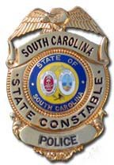

Table of Contents

Section Page
Welcome 2
Purpose 2
Meetings 2
Agencies Supported 3
Website 3
Organizational Structure 3
Uniforms 3
Uniforms – Class A 4
Uniforms – Class B 5
Duty Gear 6
Weapons 7
Work Opportunities (example listing) 8
Reports 9
Final Thoughts 9
Appendices

Incident Report Appendix A

Use of Force Report Appendix B

Quarterly Report Appendix C

Information Guide

Welcome

Welcome to the SC Constables Association Upstate (SCCAU) also known as District 3. We are glad you have decided to serve your state and your community through volunteer law enforcement service. For your benefit, this Information Guide is intended to answer many questions that new members typically have.

Disclaimer: This guide is an unofficial document and does not reflect any official policies as directed by the State of South Carolina, SLED, the Office of the Governor, or the SC Constable Association Upstate as a whole. An official SLED policy manual for SC State Constables can be found at www.sled.sc.gov

SCCAU enjoys good professional relationships with several area law enforcement agencies. These agencies are very receptive to the Constable program because of the professional reputation that has been established over the years. Through our service we can convert normal one-man patrol units to two-man units, which increase officer safety while on patrol, and allow the departments to better utilize available manpower.

Purpose
The purpose of the SC Constables Association Upstate is to assist local and state law enforcement in its daily operations, during special events, and during periods when extra manpower is needed. As a law enforcement officer in the state of South Carolina, it is expected that you will exercise your authority with discretion as outlined by the manual provided by SLED at the time of your application.

Meetings

The SC Constables Association Upstate typically meets on the first Tuesday of each month from 6-9 PM at the 3 Rivers Baptist Church, 7452 Broad River Rd, Irmo, SC 29063. Meetings are sometimes held at other locations when training purposes require specialized facilities.
Meetings typically last about 2-3 hours and consist of a training session followed by an informational session and possibly a business meeting.

Agencies Supported

Sheriff
Edgefield County PD
Lexington County Camden
Richland County Elgin
Calhoun County Ridgeway
Kershaw County Ridge Spring
Newberry County Burnettown
Fairfield County Salley
Wagener
Pelion
Chapin
Cayce
West Columbia
St. Matthews
Columbia
Columbia College
Ft. Lawn
Forrest Acres
Ridgeway Spring
Springdale
South Congaree
North Augusta

To work with one or more of these agencies you must be on a pre-approved work list. You need to see the district Sergeant to begin this process as some agencies have specific requirements you must meet prior to being approved.

Organizational Structure

SC Constables Association Midlands has one elected officer, a District Director who acts as president. The District Director also serves as the liaison between SCCAU and SLED.

The District Director appoints other officers as he sees fit. They usually consist of one or two Lieutenants who serve as his second-in-command, a Chaplain, Treasurer, Secretary, and Quartermaster (supply guy), and Sergeants who take the lead as the contact for each of the agencies supported.

It is important to note that rank is never worn while working with law enforcement agencies, and rank does not give any disciplinary authority over other constables. Rank is granted as a title of respect to those who are willing to serve in a leadership capacity, and to help define the organization in a fashion similar to conventional law enforcement agencies.

Uniforms

There are two basic uniforms that are worn while working in support of our local agencies. The Class “A” uniform is the uniform that is to be worn while working any standard duty assignment unless informed otherwise by the agency you will be sporting.

Uniforms - continued

“Class A’s”

The Class “A” uniform consists of a dark navy blue (midnight blue) button-up uniform shirt (short sleeve and/or long sleeve), and dark navy blue uniform pants, State Constable’s badge, State Constable shoulder patches on each shoulder, “POLICE State Constable” patch on the back, “SC” collar brass, name plate, duty belt, and black shoes. A dark navy-blue tie is also included in the long sleeve version of the Class “A” uniform. A picture of the Class “A” uniform can be found below. In the Duty Gear section of this document, you will find a complete listing of the Class “A” uniform components, along with suggested sources where these items can be purchased.

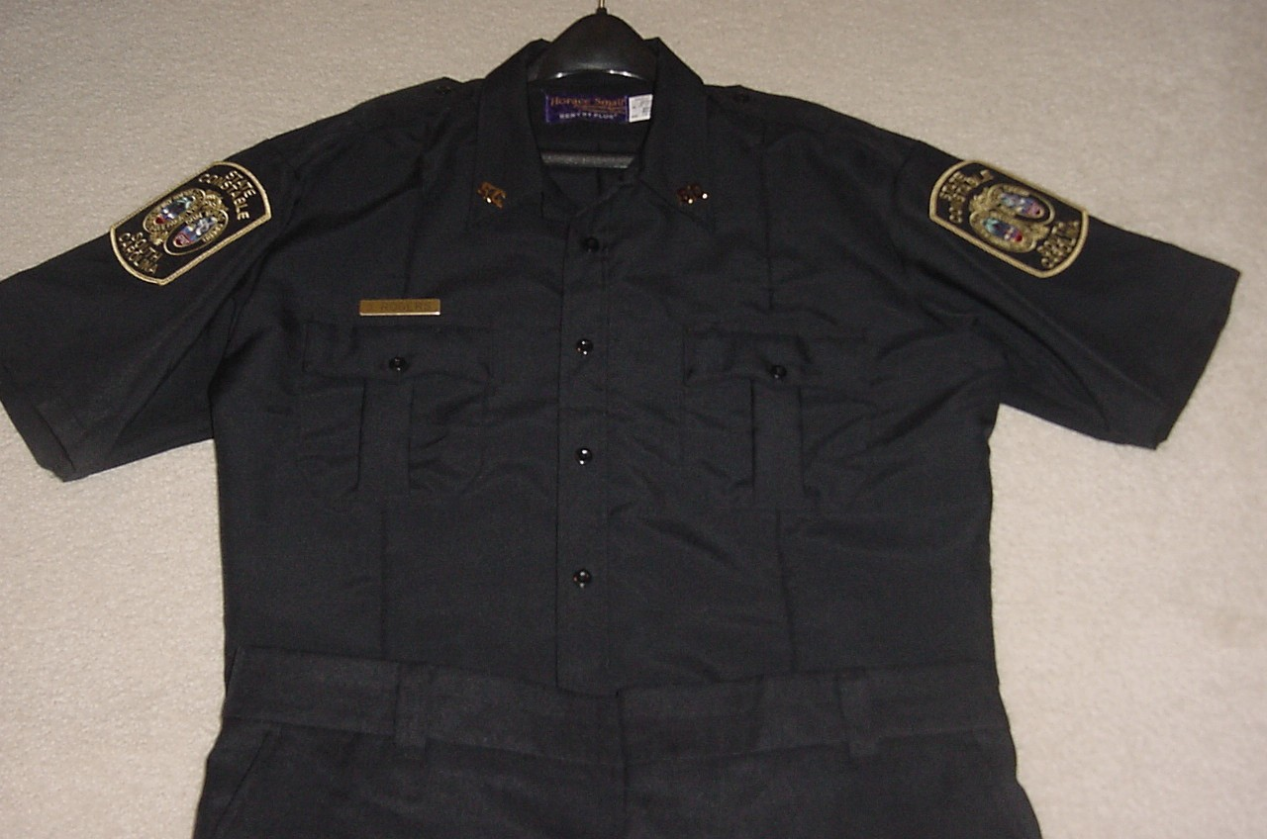

Ballistic vests are required to be worn while on patrol and in uniform whether it is Class “A” or Class “B”!!!

Uniforms - continued

Class “B”

Class “B” uniforms are only worn when approved by the agency. Some agencies, such as Lincolnville Police Department, approve the Class “B” uniform as the normal work uniform. The Class “B” uniform consists of black/dark navy blue BDU pants, a grey golf/polo style shirt with the constable’s badge embroidered on the left front chest, “POLICE State Constable” embroidered on the back, black shoes (typically jump boots), and the duty belt. A picture of the Class “B” uniform can be found below. In the Duty Gear section of this document, you will find a complete listing of the Class “B” uniform components, along with suggested sources where these items can be purchased.

There is also a black Class “B” BDU shirt that may sometimes be worn when working in rugged conditions such as during wooded search and rescue operations. This uniform shirt has the badge embroidered or sewn on the left chest, with the Constable’s name on the right chest, and “POLICE State Constable” embroidered on the back in order to increase visibility, and State Constable patches on the shoulders.

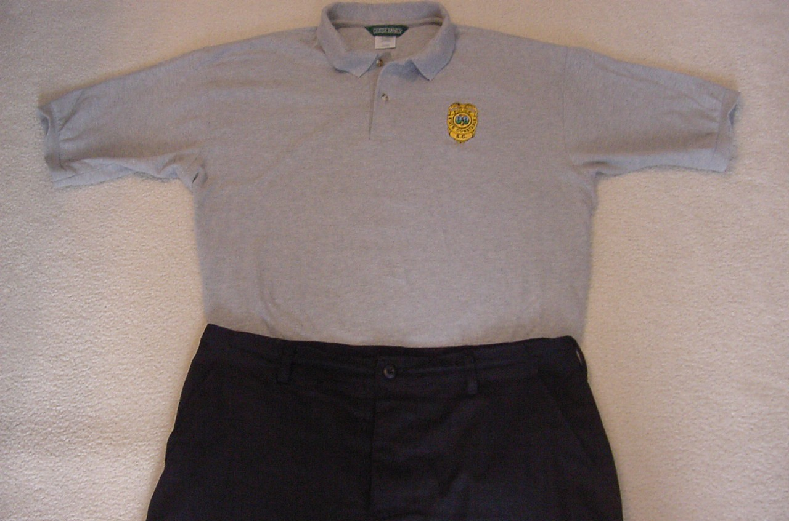

Ballistic vests are required to be worn while on patrol and in uniform whether it is Class “A” or Class “B”!!!

Duty Gear

The duty gear listed below is offered as a recommendation, and does not represent a required list. The sources where the items can purchased are not endorsements for the retailer, but are intended as suggestions where other Constables have located this gear in the past. Duty belts and accessories can be leather or nylon. Most constables use nylon because of the price, it is lighter weight, and is pretty durable.

Class “A” Uniform

Item | Specification | Potential Local Source
Badge | Blackington Model B544, or equal | ConstableStuff.com
Shirt | Dark Navy Blue (LS-winter; SS-Summer) | ConstableStuff.com
Pants | Dark Navy Blue | ConstableStuff.com
Collar Brass | Letters SC, gold in color | ConstableStuff.com
Name Plate | Gold in Color | ConstableStuff.com
Shoulder Patches |  | ConstableStuff.com
Back Patch |  | ConstableStuff.com
Campaign Hat | Navy Blues, Straw | ConstableStuff.com
Hat Badge | Smith & Warren | ConstableStuff.com

Class “B” Uniform

Item | Specification | Potential Local Source
Shirt | Grey golf shirt, embroidered badge on chest | ConstableStuff.com
Shirt | Navy Blue/Black BDU | ConstableStuff.com
Pants | Navy Blue/Black BDU | ConstableStuff.com

Miscellaneous Duty Gear

Item | Specification | Potential Local Source
Body Armor  Inner Duty Belt | Threat Level II or better (see pg. 7) | Various Web Sites  See below for web sites
Sam Browne Belt
Holster | Double or triple retention recommended!
Hand Cuffs | Use S&W, Peerless, or another reputable brand
Cuff Case
Glove Pouch | For latex gloves
Double Mag Case
Flashlight Holder
Black Jump Boots
Traffic Vest | Required when working traffic at night
Traffic Flashlight | For working traffic at night

You may also find much of this gear available in Columbia at Lawmen’s or Wright-Johnson, or online at ConstableStuff.com, Galls.com, QMuniforms.com, CopsPlus.com, CHIEFsupply.com, or another online retailer. Be patient. Duty gear gets expensive and does not have to be acquired all at once.

Weapons

Pistols

When working with local agencies, your choice of defense weapons is important. Your duty weapon, and any back-up/off/duty weapons, must be chambered in a caliber approved by SLED (.38 spl, .357 mag., 9 mm, .40 S&W, or .45 ACP) and must be one you qualified with.

OC / “Pepper Spray”

If you decide to carry OC or any similar chemical defense spray it MUST be approved by the agency you are working with, and you must be trained and certified to carry it. It is important to note that an OC approved by one agency may not be approved by another, as some OC sprays are water-based and some are solvent-based. Solvent-based OC’s are not to be carried with a department that utilizes Taser® X26 devices as the solvent-based OC may ignite when utilized in conjunction with the Taser® X26.

ASP/PR-24 Batons

ASPs are the expandable batons most agencies now carry, whereas the PR-24 is the “nightstick” that was replaced. Some agencies may still utilize the PR-24, but just as with the Pistol and OC, you must be trained and certified to carry these weapons while on patrol, and the agency must approve.

Training
To better equip Constables to assist full-time law enforcement agencies in a professional manner, SSCAU attempts to provide training to its Constables at each meeting. This training may take the form of videos, seminars or hands-on training.
Additionally, several of the local agencies keep SCCAU apprised of its training schedule and invites working Constables to participate free-of-charge, assuming space is available.

To meet the state yearly training requirements, SSCAU also conducts the required legal update, pistol qualification, CDV and Blood borne pathogens annually.
Dedicated, academy certified instructor for other training as needed.

Work Opportunities

SSCAU enjoys good working relationships with many local law enforcement agencies in the Upstate of South Carolina. Because of this relationship, a Constable should have no problem finding work opportunities on any given day. To get a duty assignment, you first must be on the approved work list for that department. This is accomplished by submitting your name, Call #, and SLED ID to the District Sergeant or coordinator for the agency(s) you wish to work with. Once your name is submitted and approved by the department you are ready to go. Keep in mind that some agencies may have additional requirements to work with them, and the approved work lists are only updated twice per year. The Sergeant should be able to provide you with any specific information or requirements for their respective agencies.

Check with your respective agencies for events.

Reports

You are required to file your Quarterly Report with SLED by the 15th day following the end of the calendar quarter for any assignment where you utilize your commission. You should keep a copy of this report for your records, and a copy should be given to the Lieutenant (Director of Training). SCCAU will compile these reports and enter hours worked into a database so we can track hours worked for each agency in each quarter and annually.

Use of Force Reports and Incident Reports should be filed with the SCCAU Captain ASAP! A copy of the Quarterly Report, Use of Force Report, and Incident Report are included in the appendices of this document for your use.

Final Thoughts
This guide has been developed to answer many of the questions new Constables have, but you will learn best by getting involved, being frequent in your attendance, and asking questions of others. If you have any time, abilities, specialized training, or resources you can offer to SSCAU please feel free to share them with the leadership, as we are always in need of capable volunteers.

Work opportunities in SCCAU will likely be limited more by your time and availability rather than by the agencies we support. We enjoy this benefit due to the hard work, dedication, and professional work ethic of other Constables who laid the groundwork.
Each time you report for a duty assignment, your conduct reflects on other Constables who share your interest in community service through law enforcement. Always strive to put your best foot forward in order to continue the professional reputation that others have worked so hard to develop.

God Bless the “Thin Blue Line.”

Appendices

INCIDENT REPORT
THIS FORM MUST BE SUBMITTED TO YOUR CAPTAIN WITHIN 5 DAYS OF REPORT DATE

NAME: SS# Call Sign:

Incident Type: Date of Incident:

Was Force Used? Yes: No: Type of Force Used?

Department or Agency you were working with?

Officer you were working with? Officer’s Badge or Unit #

Parties Involved in the incident? Party #1 Party #2

Names: /

Addresses: /

/

Phone #’s: /

Nature of
Incident: Location:

Narrative:

Signed: Report Date: / /

Reviewed By: Date: / /

Use of Force Report
Date of Incident: Time of Incident: Environmental Conditions:

State Constable Name: Call Sign:

Agency Supporting:

Working with Officer(s): Badge/ID #

Activity:

Other Officers/Constables Present:

Type of Force Used

OC Spray Expandable Baton Firearm Discharged

No. Rounds Fired Other

Detailed Description of Use of Force: Include justification, how force was used, who was force used upon, location, time, names and race of all people present, injuries, medical attention given, other reports filled out and recipients. Be as specific as possible. Attach additional sheets if needed.

Suspect(s) Name: Alias(s):

D.O.B. Race Sex Height Weight

Eyes Hair DL# State

Address:

Witness(s) Name: Alias(s):

D.O.B. Race Sex Height Weight

Eyes Hair DL# State

Address:

Witness(s) Name: Alias(s):

D.O.B. Race Sex Height Weight

Eyes Hair DL# State

Address: Suspect(s) Actions upon your arrival (Be very specific):

Officer/Constable’s Reaction (Explain how you felt, why you took the course of action you did):

Medical Treatment
E.M.S. Called to Scene. _ Yes _ No Reason:

List of E.M.S. personnel:

Suspect(s) Injuries

Type of medical treatment to suspect(s):

Suspect released to: _ Jail _ Hospital

Officer/Constable’s Injuries

Type of medical treatment to Officer/Constable(s):

Constable’s Signature: Date:

Officers Signature: Date:

Copies to: Officer working with the Constable SCCAU Captain
Constable’s Personal Records SLED

SCCAU
Use of Force Report Page 2 of 2

STATE CONSTABLE QUARTERLY REPORT
Name: Date:

Address: City: Zip:

AD# Telephone: Day Night

Current Employment:

List all use of your commission during the last quarter. Use reverse side if needed.
Date | Agency | Patrol | Special Event | Training | Meeting | Commute | Other ¹

TOTALS
Last in-service training: Date: Location:

I CERTIFY THAT THE ABOVE INFORMATION IS TRUE AND
COMPLETE.
Date Signature

Date | Agency | Patrol | Special Event | Training | Meeting | Commute

TOTALS

_
¹ Explain “Other” Hours:

UCTIONS

- REPORTING DATES: SLED must receive from every constable within thirty days of January 1, April 1, July 1 and October 1 of each year, a quarterly activity report for the quarter just ended. Failure to submit a timely report certifies to SLED that the constable did not use his or her commission authority during the reporting period. Failure to timely report use of constable authority is a violation of SLED policy and can result in suspension or revocation of a

commission.

- COMPLIANCE WITH POLICY: A constable’s signature on a quarterly report certifies that the constable has read, understands and is in compliance with all SLED policies governing state constables.

- ACTIVITY REPORTING: A constable must make a report entry for each time assistance is given to an agency, department or officer. The “DATE” column must contain the date the work was performed. The “AGENCY” column must contain the name of the agency or department assisted. The constable must enter the number of hours spent on each activity in the appropriate column.

- POLICY: Constables are authorized to take law enforcement action in the following circumstances only: (1) To assist a law enforcement officer who requests assistance or who is in imminent danger, (2) to take appropriate action in response to an imminent and urgent threat to public safety or (3) when working an assignment pre-approved by SLED.
- Submit reports to: SLED Regulatory Services, PO Box 21398, Columbia, SC 29221-1398, (803) 896-7015.

Form R-163 Revised: 04/12/2019

